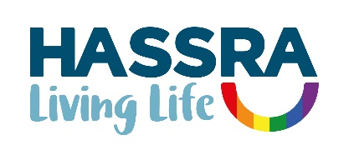

**Annual Report 2023**

|  |  |
| --- | --- |
| **Contents** | **Page** |
| Presidents | 3 |
| Glossary | 3 |
| Foreword | 4 |

1. Summary 5
2. National Programme 5-9
3. Building Membership 9
4. Supporting Clubs and Volunteers 10-11
5. Promoting Equality and Diversity 11
6. Building Sponsorship 12
7. Building our Business 12-13
8. Managing our Business 14-15

Appendices

1. National and Regional Management Committees 16
2. 2023/2024 National HASSRA Decision-Making Bodies 17
3. Awards Committee Report 18-19
4. Programme and Delivery Committee Report 20
5. Finance Committee Report 21
6. Diversity and Inclusion Committee 22-23
7. Membership Benefits 24-30
8. HASSRA Membership 31-34
9. HASSRA Live Visitations 35
10. Finance Transactions 36
11. Online Programme MI 37-38
12. Development Fund 39
13. Charity Fundraising 40

**President**

Peter Schofield CB, Permanent Secretary, Department for Work and Pensions

**First Vice President**

Sir Chris Wormald KCB, Permanent Secretary, Department of Health and Social Care

**Glossary**

AC Awards Committee

AGM Annual General Meeting

BOM Board of Management

CCM Contactless Card Machines

CMT Communications and Marketing Team

CSiS Civil Service Insurance Society

CSSC Civil Service Sports Council

DHSC Department of Health and Social Care

D&I Diversity and Inclusion

DWP Department for Work and Pensions

FACT Financial Control and Assurance Team

FC Finance Committee

HDF HASSRA Development Fund

IA Inter Association

LGBO Lesbian, Gay, Bisexual and Other

MI Management Information

PDC Programme and Delivery Committee

# Foreword

It’s been a busy year for HASSRA once again!

Recruiting new members remains our highest priority and thanks to the fantastic efforts made by clubs, regions and nationally the outlook is much more promising now than at the beginning of last year. If recruitment continues its present trajectory, we will reach our ambition to have 60,000 members by December 2025.

It’s never been more important for members to save money as the cost of living increases and members’ feel the squeeze. Our regular Summer Promotion was as popular as ever, but members buying habits changed as they purchased more of the less expensive attraction tickets and fewer expensive ones. Clearly saving members money is really important to us and we are always looking to expand our membership benefits portfolio by following up suggestions from members. If you have any ideas for new and exciting membership benefits, please let us know. Although it might not always be possible to strike a deal, we will always try our best.

In addition to our national flagship HASSRA Festivals, our programme of local sports and leisure events continues to engage with members across the country. We are grateful to our army of volunteers without whom this would not be possible. If you want to get involved, we would love to hear from you!

We have also continued to build on our on-line events programme including regular puzzles and smart quiz. These competitions are always really popular with members and are so important as they are accessible to everyone and reinforce our inclusivity commitment. These are all available on our digital platform HASSRA Live which is continually growing with new functionality. Last year we released a function to organise raffles which has already proved popular. Many more exciting features will be released this year including a social media platform which will allow members to interact with each other.

This report gives much more detail of what has been achieved last year. Please take some time to read more of the detail.

Dave Barrow

HASSRA National Chair

May 2024

# Summary

1.1 Formed in 1935, HASSRA has been providing sports and leisure opportunities to staff in

DWP and DHSC and associated agencies for 88 years. It is a national organisation of 58,000 members with income of £3.7m, and strong foundations in 353 local clubs organised in 12 regions. Operating on this scale gives HASSRA a formidable delivery capability unrivalled amongst public sector staff associations. Our aim is to provide broad range of sports and leisure opportunities at work and at home which helps members achieve a happy and healthy work-life balance. HASSRA supports DWP’s vision to make DWP a great place to work.

1.2 In 2023 that included:

• benefits, discounts and offers worth **£5m**

• HASSRA Lottery paying out a guaranteed £756k plus a double money draw worth an extra £63k

• free draws and competitions worth £121k

• fortnightly prize puzzles and monthly on-line quizzes live on YouTube

• national and regional sports and fitness, arts and crafts and cultural activities

• local office and single activity club programme of sports and leisure events

• a Development Fund awarding £8,545 to help members achieve their potential

• three HASSRA Festivals (April, July and September) hosting 1,252 members and volunteers

• and much, much more totaling 247k member participations in 2023.

1.3 This report describes these activities in the period year ending 31st December 2023. It broadly follows the format of the 2023 HASSRA National Work Programme to help readers view outcomes against objectives.

# National Programme



***We deliver***

*HASSRA delivers a diverse programme of sporting and social activities at our popular Festivals, plus various regional and local events - bringing members with shared interests together to compete, network and thrive.*

# We care

***We care***

*HASSRA offers members a range of discounts including household items, holidays and days out, ensuring more money stays in their pockets. Members save even more with our Summer Promotion, plus lots of chances to win in our regular competitions and Lottery.*

# 2.1 The HASSRA Awards Dinner is always the highlight of the HASSRA calendar because it’s when we reward our fantastic HASSRA volunteers and showcase the fantastic achievements of our regions and clubs. We introduced two new awards Best Newcomer and Best Innovator in 2023. We want to reward more volunteers for their outstanding contributions to the health and wellbeing of other staff so watch out for more awards in the coming years.

## National Conference and Awards Ceremony

2.2 The Annual Conference was held at Warwick University on Thursday, 11th May 2023. 68 delegates, officers and observers attended the meeting. Three motions were submitted, and elections were held for BOM, FC and AC vacancies.

2.3 The Awards Dinner was held on 11th May 2023 at Warwick University. The winners from 2022 are listed below.

|  |  |
| --- | --- |
| **HASSRA Major Awards** | **Winners for 2022** |
| **The President’s Trophy**  for Best Association  **Highly Commended** | Yorks and Humber  South East |
| **Sir Philip Rogers Trophy**  for Best Large Club | John Street HASSRA (North East) |
| **Sir Michael Partridge Trophy**  for Best Small Club | HASSRA Bridlington (Yorks and Humber) |
| **Rachel Lomax Trophy**  For Best Volunteer | Lyndsey South (Yorks and Humber)    Nigel Williams (Wales) |
| **Sir Leigh Lewis Trophy**  for Best Contributor | Susan Sewell (North East) |
| **Lesley Strathie Trophy** for Best Business Sponsor | Karen Dooley (Yorks and Humber) |
| **Andy Graham Trophy**  for Best Newcomer | Charlotte Stockdale (South East) |
| **John Nunn Trophy**  for Best Single Activity Club | HASSRA NE Trips (North East) |
| **Terry Green Trophy**  for Best Sportsperson | Ian Denton (Yorks and Humber) |
| **Sir Robert Devereux Trophy**  for Wellbeing | HASSRA Plymouth (South West) |
| **Best Innovation Trophy** | HASSRA Wrexham (Wales) |

**HASSRA Online Programme**

## *Let’s Get Moving- Strava Challenge*

2.4 Two standout categories defined this year’s event: the longest single ride, an impressive 280 kilometers, and the longest overall distance, an astounding 2226 kilometers.

The cycling enthusiasm did not stop there. The incentive of twenty £50 prizes awarded to participants who embraced the overall challenge, further fueled the competitive spirit. 53 cyclists completed a total of 13,585.55 kilometers, showing the commitment and passion of our cycling community.

## *National Art Competition*

2.5Following the previous success of the online format, the art competition was hosted on HASSRA Live during August and September. Once again, there was no shortage of talent and hard work, with over 80 entries in the categories of painting, drawing, and mixed media & 3D. This year saw the introduction of an all-member vote to decide prize winners who shared £1,690 in prizes. Every entry can be viewed on HASSRA’s Flickr pages and winning images in the HASSRA Live Online Events section.

## *National Photography Competition*

2.6 This is another national competition that has been held virtually over the last few years. We again invited members to submit their photographic entries online during August and September. We received almost 600 images of an exceptionally high standard in the categories of Landscapes, People & Animals and Architecture. Again, an all-member vote decided prize winners who shared £1,950 in prizes. Every entry can be viewed on HASSRA’s Flickr pages and winning images in the HASSRA Live Online Events section.

***Let’s Get Singing***

2.7 Our ‘Let’s Get Singing’ sessions via Teams saw nearly 400 participations throughout 2023. This was considerably down on 2022’s take up which could be due to the change in members’ working patterns and their ability to take part in open office environments. This initiative will be subject to further promotion in 2024 with a review at the midyear stage for continuing viability.

## *Monthly Quiz*

## 2.8 Hosted on the HASSRA YouTube channel by our partners at Redtooth, these fun and interactive monthly quizzes attracted over 2,000 participations during 2023 and paid out over £7,000 in prizes to over 300 winners. This popular format will continue throughout 2024.

## *Fortnightly Puzzles*

## 2.9 Lots of HASSRA members continued to take part in our puzzles throughout 2023. With emojis, abstract pictures, anagrams, word searches and other conundrums, there were 15,000 participations and over 500 winners sharing nearly £6,000 in prizes, making this an extremely engaging and popular offering in 2023. Puzzles will continue through 2024.

## Christmas Cracker

## 2.10 The 2023 winter promotion was a hugely popular free prize draw for cash and electronics. With a record 19,000 entries during October and November, two hundred lucky winners shared £50,000 worth of prizes, all delivered in time for Christmas.

## Fun ‘n’ Free Competitions

## 2.11 In addition to the foregoing, we ran 30 competitions which attracted a total of over 250,000 entries. Nearly 500 winners shared over £35,000 in prizes, including several complimentary or discounted offerings from commercial partners.

## Development Fund

2.12 During 2023 members received awards totaling £8,345 (including £3,000 kindly provided by The CSiS Charity Fund). This represented an increase in the value of awards of £1,645 (25%) over the previous year. A breakdown of awards by region can be found at appendix 12.

## Summer Promotion

2.13Our usual Summer Promotion was launched on 1st June and offered heavily discounted theme park and attraction tickets. We saw a change in members’ buying habits from previous years and sold fewer tickets for Blackpool Pleasure Beach – one of our most expensive tickets – and more tickets for other cheaper attractions. This resulted in lower costs enabling us to extend the end date from 31st August to 30th September. Although we sold fewer Blackpool tickets than usual, it was still our most popular attraction. In total we sold 25,000 tickets and delivered member savings of £393k.

2.14 In addition to the national funding, regions were invited to contribute some of their own funds to further subsidise the cost of tickets to their members. North West and Y&H took up this invitation and saved their members an additional £29k and £15k respectively.

**Lottery**

2.15 After the previous record-breaking year, our lottery scheme continued its remarkable growth with 8,906 applications for new or increased tickets - an increase of 238 (+3%) from the previous year. For the second year in a row, we held a Double-Money draw in October where every winner received twice as much prize money as usual. This saw one lucky member scoop a massive top prize of £30,000. The Double-Money draw has proved so popular that we’ll be holding another one in October 2024.

*Details of all membership benefits can be found at Appendix 7.*

**HASSRA Festivals**

2.16 Three HASSRA festivals were organised during 2023 hosting 26 National Championships and seven taster events. The additional April festival was organised to accommodate some of the events from the postponed September 2022 festival. A total of 1,252 members attended the Warwick University campus during the year (March 271, July 475, and Sept 506).

2.17 We look forward to the Activity Alliance sharing their knowledge at the 2024 festivals, this will ensure fairness and inclusivity for all members in our sports and activities.

**Inter Association (IA) Competitions**

2.18 In August seven regions took part in the IA Crown Green Bowls, followed by seven regions competing in the IA Fly Angling. The ever-popular IA Indoor Cricket saw 10 regions competing for the title in Derby in September.

# Building Membership

3.1 Recruiting more members has been our top priority. We have concentrated this year on updating marketing materials and getting the message out to regions and clubs. We have also worked closely with DWP’s Wellbeing Team and DWP’s Communications Team. Recruitment has started to increase and we are now on track to reach 60,000 members by December 2025 as long as we continue on our present trajectory.

**Buddy Draw**

3.2 There was another £10,000 Buddy Draw in 2023 which saw 100 lucky new members win £50 each after a draw was undertaken following the 31st December deadline. Existing members who between them recruited the 100 new members were also rewarded with £50 each. There will be another Buddy Draw to follow in the first quarter of 2024.

**HASSRA Video**

3.3 The HASSRA promotional video which provides an engaging overview of HASSRA’s programme was updated to reflect changes in the offer and continues to be used on HASSRA Live and YouTube, and by the Association’s volunteer network, to increase recruitment and retention.

**Recruitment Materials**

3.4 HASSRA’s portfolio of leaflets and posters continue to be adapted as the overall offer changes. All materials are circulated to clubs and regions upon request ensuring that members are kept up-to-date with the latest national initiatives.

*Details of membership figures are shown at Appendix 8.*

# Supporting Clubs and Volunteers



***We Work Together.***

*With an active network of 12 Regions and nearly 350 Local Clubs run by hundreds of volunteers, we support and supplement Wellbeing initiatives with additional resources that help to make DWP a great place to work.*

* + 1. What a mammoth task! The Volunteer Toolkit is such an important tool for volunteers so revamping it to make it concise and easy to use was very important.

## Volunteer Toolkit

4.2 At the heart of HASSRA's commitment to empowering our volunteers lies the revamped volunteer’s manual. The manual provides a streamlined experience for volunteers ensuring they can swiftly find the official guidance essential for successful club and regional management.

4.3 We have designed the layout and easy-to-follow steps using the existing tiles format in keeping with other parts of HASSRA Live. Volunteers can use the new sections including a “How to Guide” as well as “A Year in the Life of a Club” and “A Year in the Life of a Region” to perform all the key tasks that need to be done in the year.

## Quarterly MI Reports

## 4.4 Comprehensive reports, providing intelligence on finance, membership, recruitment, lottery, online shop and membership benefits were issued to regions at quarter-ends in the first half of 2023 to support evidence-based decision-making throughout the Association.

## In August, regions were notified about a pause to their quarterly MI reports due to reduced national team staff resource. Quarterly finance reports continued to be issued throughout the year.

## 4.5 Work began to investigate the creation of an MI portal on HASSRA Live which would allow regional volunteers access to their information as and when required. This work is due to be continued into 2024.

## Chairs Meetings 2023

4.6 The ninth annual joint meeting of the National Board and regional chairs was held in February at Warwick University. Attendees discussed the CSSC review, business unit sponsorship and the reaching out campaign.

4.7 In a change to the calendar, National Board and regional chairs met again at Warwick University in November. It was agreed November was better suited to progress Association business than February for future meetings. Attendees discussed a potential free introductory membership offer, 2024 budget, BOM and sub committees review, and business unit sponsorship.

**HASSRA Live Club Support**

4.8 HASSRA is committed to supporting our local clubs by providing extensive training events. These sessions have been instrumental in guiding club volunteers through various functions, enhancing their skills in event management and administrative tasks.

4.9 Training events have covered various topics including setting up competitions, organising events and conducting raffles. These training initiatives equip local clubs with the knowledge and tools necessary to create activities and boost engagement.

4.10 In addition to event-focused training, we have offered ongoing support for administrative tasks. Sessions have been conducted on completing chairs certificates and uploading club accounts. These initiatives streamline club operations, ensuring accuracy and transparency in financial reporting.

4.11 We have developed a range of training aids and videos. These resources provide step-by-step guidance and visual demonstrations to reinforce the skills acquired during training events. These aids empower our club volunteers to navigate their roles with confidence.

4.12 We have also given overviews of the HASSRA Helpdesk, where members can send questions and queries. Whether seeking guidance on event planning, administrative tasks, or any other aspect of club management, this support channel is designed to promptly address and provide assistance.

**Conduct and Discipline**

4.13 The DCC dealt with an increased number of complaints throughout 2023. There will be a full review of conduct and discipline procedures in 2024.

**Charity Collections**

4.14 During the year, members and clubs found many ways to support their favourite charities and collected a fantastic total of £122,655. As in previous years, this figure is likely to under-report the actual sum because not all clubs submit returns. We will continue to find ways of ensuring all charitable donations are recorded.

*Details of charity figures are shown at Appendix 13.*

## 5. Promoting Equality and Diversity



***We value everybody.***

*Members' feedback is key to making HASSRA a better organisation for everyone. Our Development Fund helps members overcome financial barriers to reach their goals, and our Diversity & Inclusion Policy aims to provide something for everyone.*

5.1 HASSRA has always striven to have something for everyone. This year we have set up an equality and diversity sub-committee to advise the National Board of Management what more we can do to make HASSRA even more inclusive.

## 6. Building Sponsorship

6.1 Building great working relationships with our sponsor departments is very important to HASSRA. Through those close working relationships, we can ensure our policies and procedures mirror those in DWP. We can also complement the work of the Wellbeing Teams.

## Departmental Sponsorship

6.2 HASSRA has a good working relationship with DWP’s Wellbeing Team and this year they have invited us to present the benefits of HASSRA membership to all the DWP Wellbeing Advocates. This has helped to boost recruitment.

6.3 HASSRA’s Communication and Marketing Team has forged a closer working relationship with DWP’s Communication Team and this has resulted in articles in DWP’s Connect publications which has also boosted recruitment.

**Financial Sponsorship**

6.4 The CSiS Charity Fund, who provide funding for disabled/disadvantaged members in our Development Fund, generously awarded us a grant of £3,000 for the year. This was an increase of £1,000 from the previous year. We are very grateful to the CSiS Charity Fund for their long-standing commitment to HASSRA.

# 

# 7. Building our Business



***We adapt***

*As members continue hybrid working, the HASSRA programme constantly evolves to provide a vibrant mixture of face-to-face and online events to increase engagement with colleagues and promote wellbeing and inclusivity.*

7.1 HASSRA Live continues to be our main delivery arm. In the past year, HASSRA has made significant strides in enhancing the HASSRA Live experience for our members. New functionalities have been integrated to improve the enjoyment and streamline behind the scenes operations.

## HASSRA Live

7.2 One notable improvement is the English Heritage membership process which now allows members to easily buy new membership or renew their existing membership directly with English Heritage.

7.3 Additionally, we introduced Raffles functionality to HASSRA Live. This allows clubs and regions to run their own online Raffles. Making this process easy and accessible has proven to be a popular addition.

Behind the scenes:

1. We now can update the wording for system emails. This allows us to make the automated emails less formal.
2. We have also added an automated notification which sent to regional expense approvers to notify when there are expenses awaiting approval. This has reduced the waiting time for members having their expenses approved.
3. We have also added the functionality to stop new members from registering on the site using their.gov.uk email. They are advised to use a personal email address instead. This allows ease of access when members have purchased offers, tickets etc.
4. Following feedback from volunteers we have made changes to the competitions functionality allowing for a more user-friendly experience.
5. Members who have left HASSRA now receive a survey on the reasons they decided to leave. These figures are monitored monthly to identify any trends.

7.4 In terms of infrastructure the annual penetration test has given us the added knowledge that the site is secure and robust. Improved data management protocols contribute to a stable and reliable platform, ensuring uninterrupted access to all HASSRA members.

## *See appendix 9 for visitation statistics.*

## Communications

7.5 Working closely with internal and external partners, the Communications and Marketing Team (CMT) has continued to deliver timely communications to keep members informed about the national programme and latest news stories and special offers. A brand-new media deck was created to give potential benefit partners an insight into how affiliation to HASSRA can be mutually beneficial.

**Social Media Channels**

7.6 HASSRA’s social media pages continue to play an increasingly important role in promoting membership benefits. By the end of 2023, we had 8,000 Facebook and nearly 900 X followers. Instagram grew steadily to more than 500 followers.

7.7 Flickr was once again pivotal in the judging of the National Art and Photography competitions. National HASSRA continues to collaborate with regions by hosting many of their competitions on our Flickr pages.

7.8 The HASSRA YouTube channel continues to host our monthly Smart Quizzes and is used as a platform for the HASSRA promotional video and for the circulation of recorded key Association meetings.

7.9 We have started to investigate a new HASSRA WhatsApp channel which we expect to provide a key avenue of communication in the future.

## 8. Managing our Business

## One of the key functions of the HASSRA National Team is to manage all the business functions. Although club accounts are administered by volunteers in accordance with the Staff Club’s Guide, it would be difficult if not impossible for volunteers to perform many of the regional and national business functions. These functions are performed by the HASSRA National Team.

## HASSRA National Accounts

8.1 The Association’s auditors *Dafferns* conducted an audit of the financial statements of the HASSRA National Revenue and Lottery accounts for 2023. The results are as follows:

* the national revenue account had an excess of expenditure over income of £404k
* the national lottery account had an excess of income over expenditure of £513k

8.2 As is usual, the excess income from the lottery was used to offset expenditure from the revenue accounts. This left an excess of income over expenditure of £109k resulting in a commensurate increase in national reserves, which now stand at £1.650m.

## Regional Finances

8.3 At 31st December 2023, aggregate funds held by regions stood at £1.474m - a reduction of £151k or 9% over the previous year.

## Investment Accounts

8.4 For the first time in many years, National and Regional investments yielded some notable returns because of the significant rise in interest rates during the year. Our investments are reviewed regularly to maximise returns.

**CSSC Grant**

8.5 The CSSC Departmental Association Grant for 2023 was £55k – a reduction of £20k or 26% from the previous year. Over the last decade the value of this grant has diminished from £154k to £55k. From 1st January 2024 CSSC decided to discontinue this grant, so we will no longer be able to fund entry/expenses for CSSC activities. However, CSSC have introduced a new grant for health and wellbeing projects for which we have been awarded £15k.

## Ticket Sales

8.6 We fulfilled over 10,000 orders on our online shop for 27,000 theme park and attraction tickets worth £675k, saving members on average 40% off normal admission prices.

8.7 Sales of cinema e-codes during 2023 were once again administered by our partners at The Cinema Society. Over the year, 6,000 more HASSRA members registered with The Cinema Society website bringing the total number of registered members to 31,000. In total, HASSRA members made 45,000 transactions for 129,000 e-codes worth £714k – a 30% increase from 2022 – and members saved on average 43% against normal cinema admission prices.

## HASSRA National Team

## May 2024

## 

**Appendix 1: National and Regional Management Committees**

The organisation charts below show HASSRA’s National and Regional Committees and the names of their Chairs. Members of these decision-making bodies are at Appendix 2.

## National

## 

**Regional**

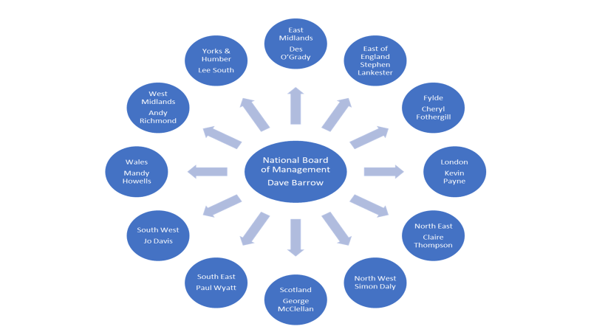

**Appendix 2: 2023/2024 National HASSRA Decision Making Bodies**

## National Officers Subject to Election

Chair Dave Barrow n/a

Operations Director Dawn Crow n/a

Finance Director Harvey Clarke n/a

## Board of Management

Chair Dave Barrow n/a

Operations Director Dawn Crow n/a

Finance Director Harvey Clarke n/a

Elected Member Nigel Thomas May 2026

Elected Member Justine Brown May 2024

Elected Member Sean Mulgrew May 2025

Elected Member Nicki Stowe May 2025

Elected Member Vacant May 2024

Co-opted Member Maria Lane

Secretariat Jenny Richardson

## Finance Committee

Chair Harvey Clarke n/a

Elected Member Di Grossey May 2026

Elected Member Helena Whitehead May 2025

Elected Member Willie Hunter May 2024

Elected Member Martin Gale May 2024

Elected Member Jay Saleem May 2026

Elected Member Sarah Fairclough May 2025

Co-opted Member Dave Lees

## Awards Committee

Elected Member (Chair) Tina Earp May 2025

Elected Member Irena Gorbun May 2024

Elected Member Vacant May 2026

Co-opted Member Marilyn McGinty

## Programme and Delivery Committee

Chair Jenny Richardson n/a

Elected Member Simon Jowitt May 2024

Elected Member Della Tucker May 2024

National Team Ann Cook

National Team Claire Metcalfe

## Diversity and Inclusion Committee

Chair Gary Thorogood n/a

Co-opted Member Steve Waters

Co-opted Member Karen Sinden

Co-opted Member Scott Porter

Co-opted Member Marie McCormick

Co-opted Member Nikki Densham

# Appendix 3: Report from Awards Committee

# I would like to begin by saying a big thank you to Ann Nash for all the work she undertook whilst on committee. Ann stood down from the committee in 2023 and her wealth of knowledge and experience has and will continue to be missed.

# The awards committee welcomed Marilyn McGinty who was elected on to the committee following the AGM in May 2023. Marilyn has quickly immersed herself in her role and has been a very welcome addition.

# HASSRA Development Fund - HDF

# In 2023, 33 HDF applications were received resulting in 32 awards being made to help towards HASSRA members development. A total of £8,545 was awarded of which £2,584 was appropriate to the CSiS Charity Fund (kindly provided for applicants who have a disability or disadvantaged). This compares to 43 applications and 22 awards made in 2022. Whilst the number of applications received is slightly less, I believe the high number of successful applications can be attributed to the hard work of both the National HASSRA team and the AC on ensuring members fully understand the criteria and application process.

# Activities members are requesting support for have been incredibly varied, ranging from main stream sport to podcasting and qualifications to support Special Educational Needs. For me this shows that the HDF is multifaceted and it’s reach is appealing across the whole of our membership.

# The AC will continue to work with the National HASSRA Board of Management and National HASSRA Team to ensure that the HDF continues to be attractive to current members as well as a draw for encouraging new members.

# National HASSRA Awards

# There was a slight reduction in the number of submissions received for National Awards in 2023 and it was disappointing that some regions were unable to submit entries in each of the categories. The AC have reviewed and will continue to review the submission process in an attempt to make it as streamlined as possible, but without jeopardising the opportunity for Regions to give a full and clear description of activities undertaken.

# The AC, with agreement from the National BOM, made some adjustments to the criteria for both the Best Region and Best Local Club awards. It is anticipated that this will help regions and clubs to focus on the key areas and have more of an understanding of what the AC consider when judging submissions.

# There have been some notable changes to the way in which two of the awards are voted for this year, the Best Arts, Crafts and Non-Sporting Contributor and the Best Sportsperson will be voted for by members via HASSRA Live. It is hoped that this will encourage submissions from every region and will also engage members in the process, thus raising the profile of our National Awards. This will be reviewed collaboratively by the AC and the National BOM and any adjustments/improvements will be made ahead of the 2024 process.

# New for 2024, we have also introduced HASSRA Heroes. Recognising that HASSRA, nationally, regionally and locally, relies on volunteers to dedicate their own time and commitment to supporting members and delivering an extensive package of benefits, events and activities. This is someone who would not be considered for the Volunteer of the Year Award, but their contribution enables members to get a fantastic member experience. No matter how big or small, everything volunteers do supports our members and contributes to their member experience. Regions have also been invited to bring two HASSRA Heroes to the awards dinner this year.

# I would like to thank Irena Gorbun, Marilyn McGinty and Dawn Crow for their significant contributions during 2023. I would also like to thank the National BoM and the National HASSRA team for their continued support of the work of the AC. I would also like to acknowledge and thank our regional committees, regional and local volunteers for their hard work and dedication to the National HASSRA Awards, I wish you all the very best of luck.

# In 2024 I would like to see an increase in HDF applications and would like to work with regions on how we can encourage more applications. I look forward to reading about the achievements of our 2023 recipients and how the HDF made a difference.

## Tina Earp

## Committee Chair

**Appendix 4: Report from Programme and Delivery Committee**

The Programme and Delivery committee met in October to review the 2023 April, July and September festivals. The meeting also looked at the proposed events for the July and September festivals for 2024. The forthcoming festival review was discussed, and it was confirmed PDC members would be involved to provide their knowledge and experience.

The PDC were keen to incorporate some of the events previously hosted by CSSC into the HASSRA national programme, including swimming and athletics. It was agreed more work was required before any extra events could be confirmed. The committee discussed the proposed walking challenge for local clubs, and this would be tied in with a national walking taster event to be held at one of the 2024 festivals.

PDC members were keen to include mixed walking football in the 2024 event line-up. It was hoped this would appeal to all members and might encourage first time attendees. The invitation to the Activity Alliance for the 2024 festivals was discussed. Their knowledge would be shared with volunteers, staff team and event organisers to enable future festivals to be even more inclusive for our members.

The use of a personal email when registering for an event on HASSRA Live was endorsed by the committee. This was a health and safety issue, as anyone registering with a work email might not be contactable should an emergency arise. This was a piece of work currently being looked at by the HASSRA National team.

Thank you to all the committee members for their contributions.

## Jen Richardson

## Committee Chair

**Appendix 5: Report from Finance Committee**

In 2023 the Finance Committee started exploring the potential for the Association to use contactless card machines (CCMs) for collecting monies from members. The Covid-19 pandemic accelerated the use of contactless card payments and CCM’s are now the norm for small businesses with customers increasingly wanting to make cashless payments. However, DWP’s Staff Clubs Guide has not kept pace with this and makes no provision for their use. The FC investigated commercial options available, focusing on security and costs. We submitted a business case to DWP’s Financial Control and Assurance Team (FACT) who agreed to us running a trial with one of our clubs, which is currently ongoing. Upon conclusion of the trial, we aim to provide FACT with the necessary assurances for them to permit the use of CCMs for the Association.

The committee held its regular main meeting in October to undertake key tasks, such as reviewing the cinema ticket subsidy, annual budget, subscription rate and lottery prize fund.

Deciding the subscription rate is always a question of balancing affordability for members while delivering a programme which continues to be valuable and supports recruitment and retention. The popularity of the double-money lottery draw and resultant income growth gave the potential to increase the annual prize fund. However, doing so would have meant having to increase membership subscriptions. So, the FC recommended retaining the existing prize fund – including another double-money draw – for a further year to fund the wider programme without needing to increase subscriptions. This recommendation was endorsed by the national board.

The FC continues to play an important role in financial planning within the Association. I wish to record my thanks to all the committee members for their contributions.

## Harvey Clarke

## Committee Chair

**Appendix 6: Report from Diversity and Inclusion Committee**

HASSRA’s Diversity and Inclusion Statement, published on HASSRA Live, is clear and purposeful in setting out the Association’s intent to provide a programme of membership benefits and services which enhance diversity and are inclusive for everyone.

By inclusive, we mean where members, have a voice and are listened to, where they feel they belong, are treated fairly and with respect and where they can be their authentic selves.

In 2022 we set up a Diversity and Inclusion Sub Committee of the National Board of Management to help bring these objectives to life.

In 2023 our initial and primary focus was to gain a deeper understanding of the demographic make-up of our membership and in turn, a greater appreciation of their interests and diverse needs. We did this through working with National colleagues involved in developing this year’s HASSRA survey and then undertaking a totally confidential deep analysis of the diversity and inclusion data and sentiment extracted from its results.

The analysis made for some interesting and thought-provoking reading. The following are some of the key points.

Data:

* Age – 63% of respondents were aged between 45-64
* Sex and Gender – nearly 71% of respondents were women
* Sexual Orientation – whilst this question had the highest proportion of ‘Preferring not to say’, 5.04% of respondents identified as LGBO
* Ethnicity – overall percentage of respondents identifying as being part of an Ethnic Minority was 9.44%
* Disability – just over 26% of respondents identified as having a disability
* Caring – almost 50% of respondents identify they have some form of caring responsibility.

Whilst in many respects the average profile of HASSRA members reflected those of the Department, there were some noticeable divergences. For example, DWP currently has a higher proportion of ethnic minority colleagues (16%) than HASSRA (9%) but HASSRA has a higher proportion of disabled members (26%) than DWP (20%)

Sentiment

Data only tells half the story, however. Sentiment analysis was also undertaken to gain a deeper appreciation of how members were feeling, and therefore better understand some of the perceived barriers they may be experiencing to accessing HASSRA’s offer. The results were fascinating and will allow us to take the action needed to make the Association an even more inclusive place to part of.

For instance, excluding those who do not take part in activities because of reasons outside of HASSRA’s scope (for example, those who are not interested in participating in sports and those who feel they do not have time) a distinct pattern emerged that there is a desire to participate in the activities HASSRA already offer, and many would like to be involved, but feel unable to for a variety of reasons.

The most common barrier for many (14%) was caring responsibilities and 1 in 8 members said they are unable to participate in sports due to ability. This divided into those who feel they are unable to participate as a result of disability and those who feel they lack physical or athletic ability in another form, including fitness or competitiveness.

Many comments expressed a desire or need for events designed for beginners /unfit people looking to make a lifestyle change.

Location was also an issue for some, along with an expressed desire to see more virtual events. This desire appears to have increased since the introduction of hybrid working.

Strikingly, and of some concern, there were a number of comments relating to colleagues attempting to be included in events but felt they were unable to because of perceived negative experiences around belonging, or feeling they were part of an ‘out group’. Some felt some events were exclusive and overly competitive.

This fascinating and sobering insight has given the Committee much food for thought and we will be feeding our recommendations through to the National Board of Management.

It is essential as an Association we continually review our national offer (events, activities etc.) to ensure they are as inclusive as they possibly can be to our members, where everyone feels they can participate, whatever their ability, level of skill or individual background, whilst continuing to extend our offer to make it as attractive as possible and as diverse as possible to as many potential new members as possible in the months and years to come.

We have also been working this year with the national DWP Wellbeing and Inclusion Team to consider whether the current criteria for the annual joint DWP/HASSRA Wellbeing Award might be expanded to also promote Inclusion in 2024 and our proposals, once firmed up, will be presented to the Awards Committee for their consideration early in the Spring.

**Gary Thorogood**

**Committee Chair**

# Appendix 7: Membership Benefits



































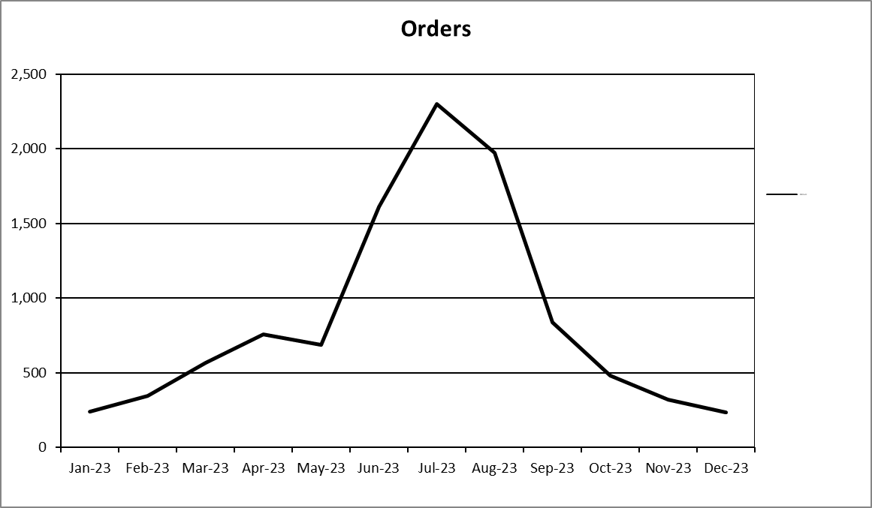

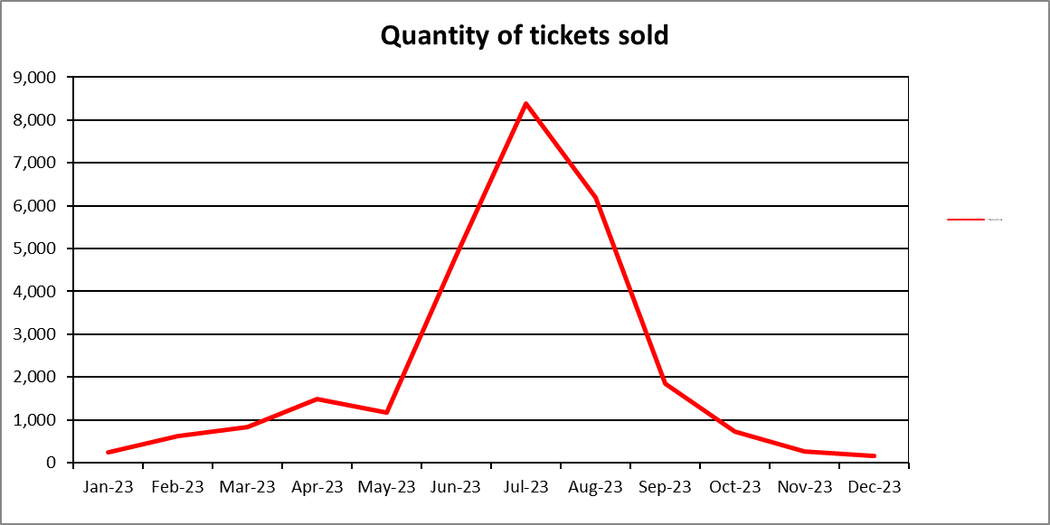

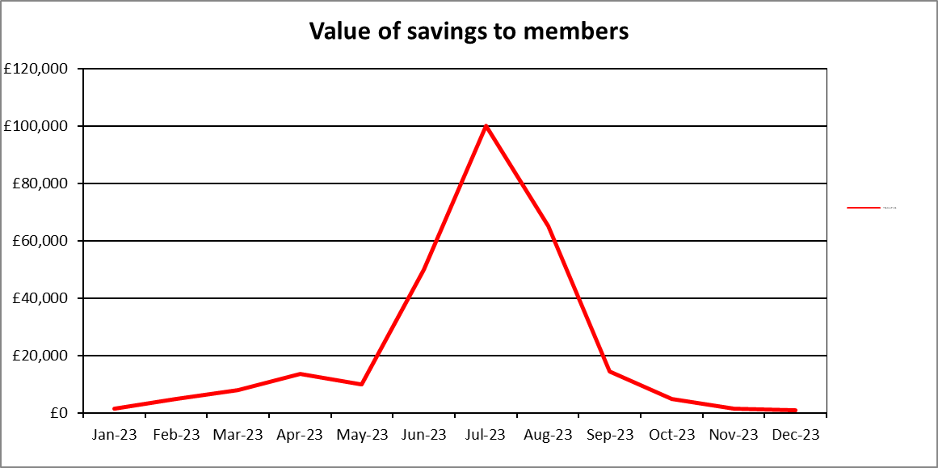



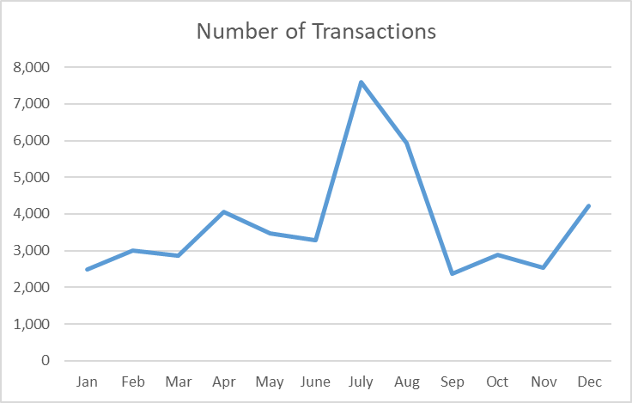

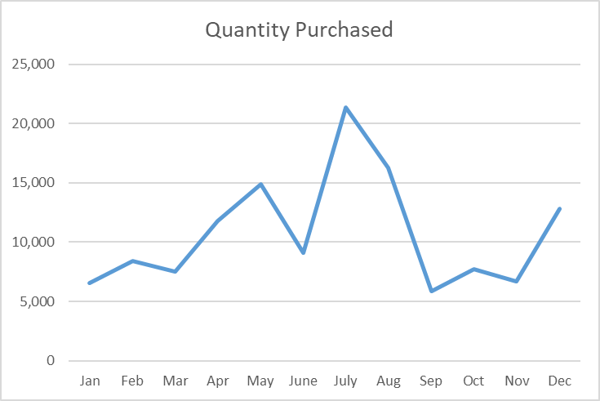

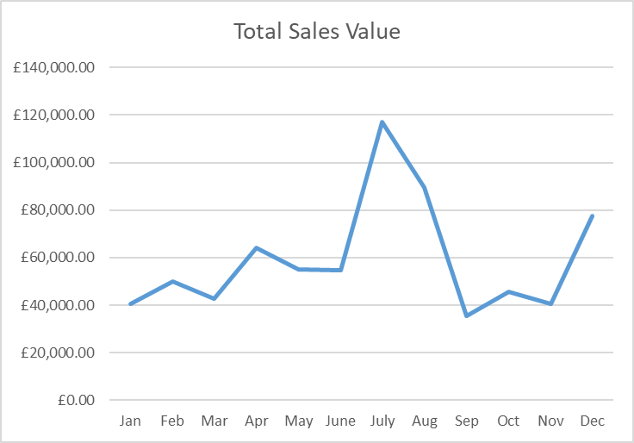

**Appendix 8: HASSRA Membership**



Membership breakdown at December 2023









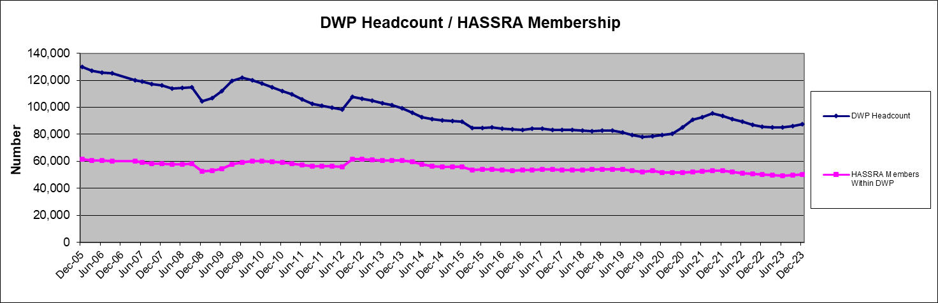

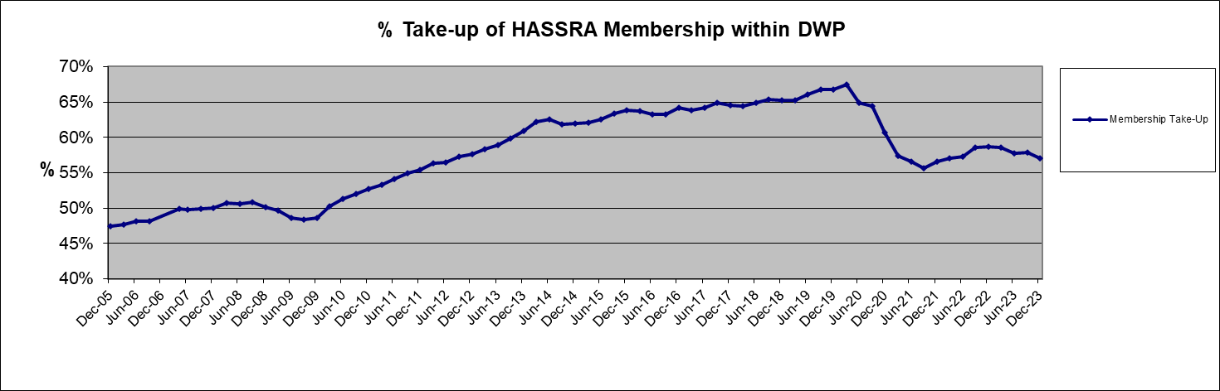

**Appendix 9: HASSRA Live Visitation**

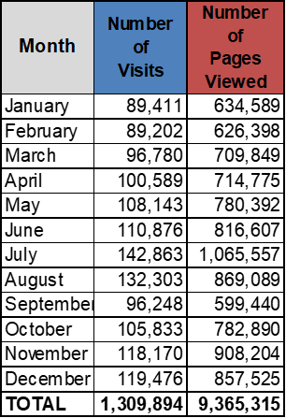

# 

**Appendix 10: Finance Transactions**



# 

**Appendix 11: Online Programme** 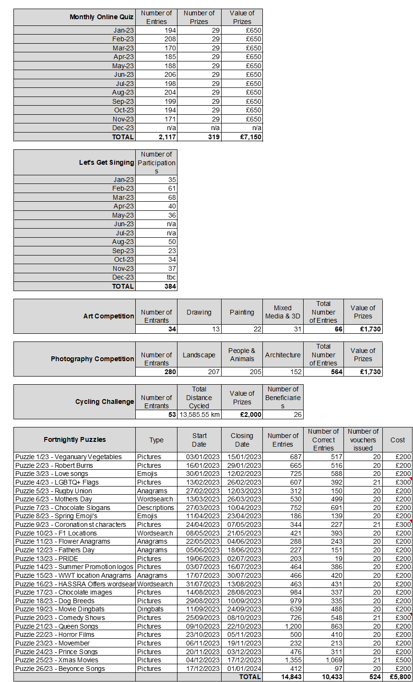

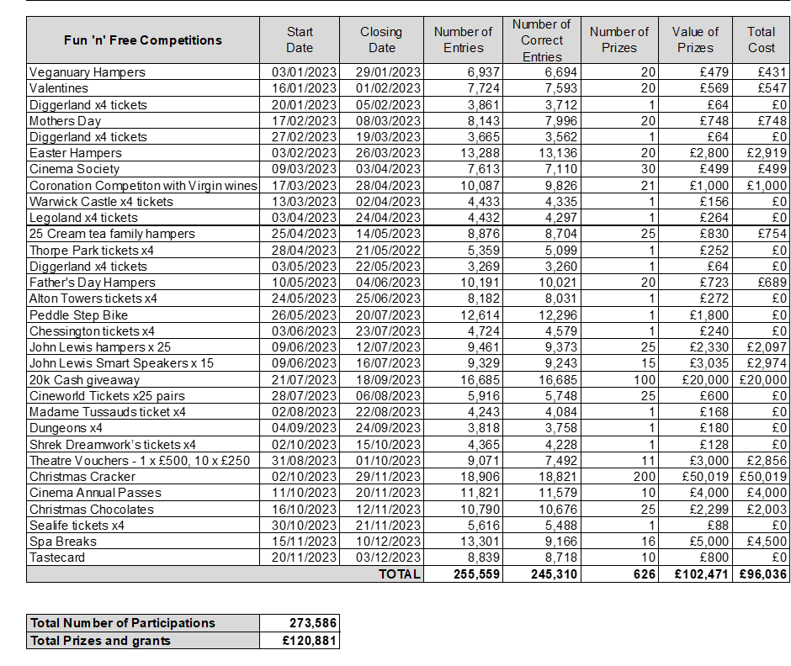

**Appendix 12: Development Fund**



|  |  |  |  |  |
| --- | --- | --- | --- | --- |
| **Region** | **Approved Applications** | **Activities** | **Total Awarded £** | **CSIS inc in total** |
| East Midlands | 2 | Footgolf*2 | £700 | £0 |
| East of England | 2 | Triathlon, Running | £550 | £0 |
| Fylde | 1 | Singing | £245 | £245 |
| London | 5 | Taekwondo, BSL, Sailing, Cricket, Arborist training | £1,675 | £0 |
| North East | 2 | Zumba instructor, Tai Chi | £750 | £300 |
| North West | 2 | Golf coaching, Cue sports | £540 | £300 |
| Scotland | 2 | Swimming coaching, Footgolf | £450 | £0 |
| South East | 4 | Ballet, Photography, Fitness, Sailing | £1,300 | £1,000 |
| South West | 3 | Fitness, Cycling, Massage | £725 | £425 |
| Wales | 3 | BMX, Athletics, Chess | £740 | £240 |
| West Midlands | 0 | NIL | £0 | £0 |
| Yorks & Humber | 5 | England Ladies Walking Football, Inland Waterways Helmsmanship, Football Coaching, Podcasting, SEND Qualification. | £670 | £75 |
| **Total** | **31** |  | **£8,345** | **£2,585** |
| One Nil decision - South East. One award not taken up - Scotland £200 (CSIS) | 33 Applications received in total. | 28 different activities supported in 2023. | Total includes CSIS Awards, excludes £200 award not taken up. | Excludes £200 award not taken up. |

**Appendix 13: Charity Fundraising**



