
President: Peter Schofield CB, Permanent Secretary, Department for Work & Pensions

To: | HASSRA Staff Team  National Board of Management  Regional Chairs and Vice-Chairs  Finance Committee  Awards Committee  Programme and Delivery Committee  Diversity and Inclusion Committee
Date: | 21/01/2025
Dear Colleagues,

2025 HASSRA ELECTORAL RULES AND NOMINATION PROCESS

- I am writing regarding the electoral rules and nomination process for elections of National HASSRA posts this year. Several files are attached which contain notes to candidates, the application form and code of ethics. They can also be found on the HASSRA website.

- We welcome applications from all our members. If you have a passion and enthusiasm for all things HASSRA and would like a say in the direction of your Association, please consider applying for one of the vacant positions. This year HASSRA is celebrating its 90th Anniversary so there are even more reasons to get involved!

3. The posts subject to election at Conference on 15th May 2025 are as follows:

- four elected members on the National Board of Management, two for a period of three years, one for a period of two years and one for period of one year
- two elected members on the National Finance Committee, both for a period of three years
- one elected member on the National Awards Committee, for a period of three years
- two elected members of the Programme and Delivery Committee, both for a period of three years (subject to the motion to Conference for two extra positions on the PDC being carried at the AGM).

Process

4. The deadline for completed candidate application forms (section 1) to jenny.e.richardson@dwp.gov.uk is 13th March 2025. On receipt of your application, it will be sent to your regional chairperson for their endorsement.

5. The deadline for endorsed applications (section 2) to be returned to me is 3rd April 2025 (the onus is on the candidate and regional chairperson to ensure the endorsed application is received by the deadline). If the regional chairperson is not familiar with the candidate, they should make enquiries with the candidate’s local club or office for clarification.

Regional Chairperson Contact Details

East Midlands harj.nandhra@dwp.gov.uk
East of England stephen.lankester@dwp.gov.uk
Fylde cheryl.fothergill@dwp.gov.uk
London kevin.payne1@dwp.gov.uk
North East claire.thompson2@dwp.gov.uk
North West simon.daly@homeoffice.gov.uk
Scotland George McLellan via HASSRA.Scotland@dwp.gov.uk
South East Paul Wyatt via HASSRA.southeast@dwp.gov.uk
South West joanna.davis1@dwp.gov.uk
Wales Mandy Howells via hassra.wales@dwp.gov.uk
West Midlands andy.richmond1@dwp.gov.uk
Yorks & Humber lee.south@dwp.gov.uk

6. Volunteers are integral to the continued success and vibrancy of HASSRA. Sharing your knowledge gained from a local club, regional or national perspective will help shape the direction of your Association.

We look forward to receiving your nomination. Should you have any questions please get in touch.

Yours sincerely

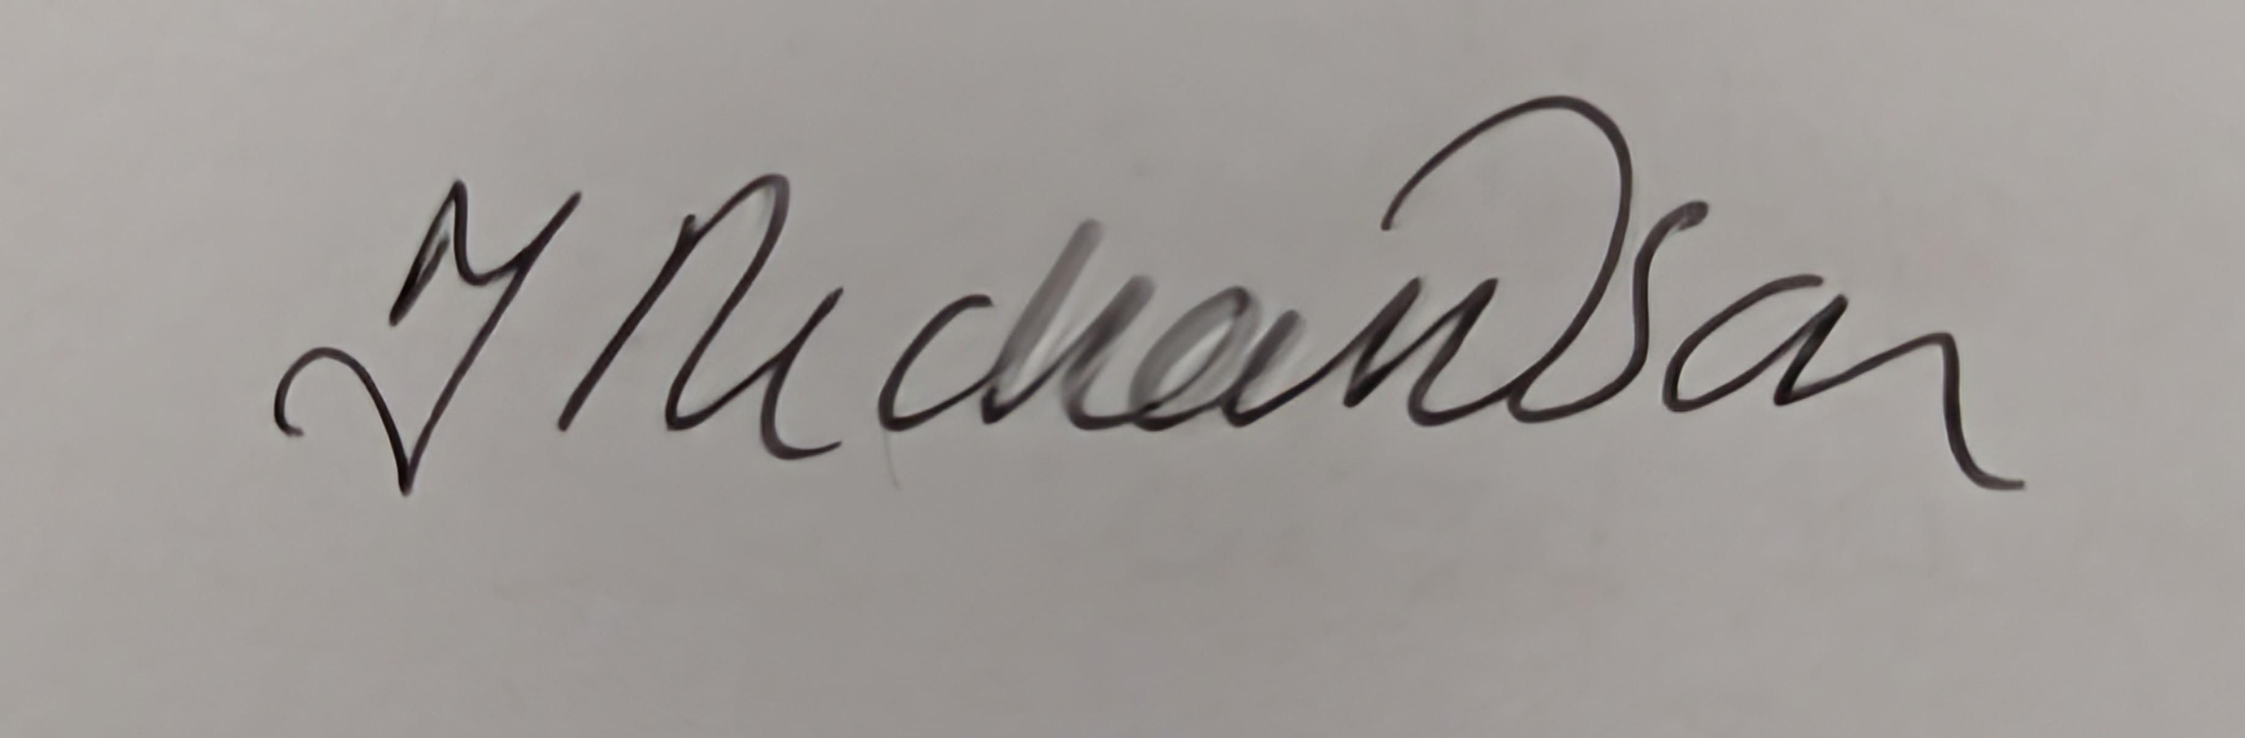
Jen Richardson
JENNY.E.RICHARDSON@DWP.GOV.UK

HASSRA National Team

