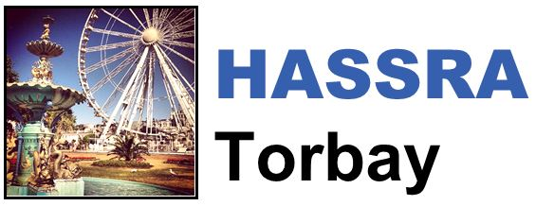

HASSRA Torbay Newsletter

Autumn 2023

Hello and welcome to the latest edition of the HASSRA Torbay newsletter

**What’s been going on?**

Your HASSRA Torbay Committee has been busy organising various activities for you to get involved in. Thank you for taking part.

|  |  |  |
| --- | --- | --- |
| **Visit a Civet Competition**  A cartoon image of a civet  Visit the Shaldon Zoo civet before the end of September and send your photo to Andrea Gilbert to enter our competition | **Site Funding**  A cartoon picture of a netball, cricket bat, tennis racket and stuttlecock  Many of our Torbay sites took up the offer of funding towards Sports and Social activities, asking for funding towards items like an on-site games table | **Tourist Wordsearch**  A cartoon image of a thatched cottage  This was our first HASSRA Torbay competition via HASSRA Live!  Well done to those who recognised “Cockington” as the missing word |



Remember, we still have our local £5 Sports Rebate and £5 Social Rebate offer running. Send proof of purchase to Helen Bridgman before 30.09.23 to claim your rebate

**HASSRA = Happiness**

In each newsletter, one of our members tells us about how they have been making the most of their membership. For this edition, we’ve been speaking toJoanne Raddon from Torquay Job Centre.

“When looking for a holiday weekend break away earlier this year, I checked on my HASSRA Live account for any discounts and offers. I noticed that HASSRA members could book a Hoseasons holiday through an exclusive discount page, giving savings of up to 10%.

I booked a Hoseasons weekend break at Leonard’s Cove in Dartmouth through this discount link and saved £22.



I had the most relaxing time and was very happy to save some money through HASSRA.

I took this photo of the sunrise – What beautiful costal views I had from this location.

If you would like to be featured in a future newsletter, email your HASSRA story and photos to Tara Sanders

**What’s coming up?**



Keep an eye out for these Autumn activities:

* HASSRA Live “Zoomed in picture” competition
* Halloween Competition
* Bonfire Night Quiz

Remember to contact Helen Bridgman to book your place on our Longleat Coach Trip on 02 December 2023.

Book now - Tickets are selling quickly.

Entry and travel costs only £30 for HASSRA Torbay members

**Featured offers this season**

Are you and your family looking to visit some spooky historic sites this Autumn? Don’t forget to check out the “HISTORY AND MUSEUMS” section, under “OFFERS”, in your HASSRA Live account for details about the following discounts:

* Discounted Cadw (Welsh Heritage) annual membership
* HASSRA code to buy discounted tickets to Wookey Hole
* Discounted English Heritage annual membership
* Pre-buy discounted tickets on HASSRA Live to Warwick Castle
* HASSRA code to buy discounted tickets to Cheddar Gorge

Remember to regularly check your HASSRA Live Account for all the latest National and South West offers and competitions: [Link to HASSRA Live](https://www.hassra.org.uk/sign-in?return_url=%2F%3FpxRatio%3D1.5&return_key=2d67aef2f8aedb0c905eedbfda14cfcccea7da3c7f09266af1d4f49828dcbac5)