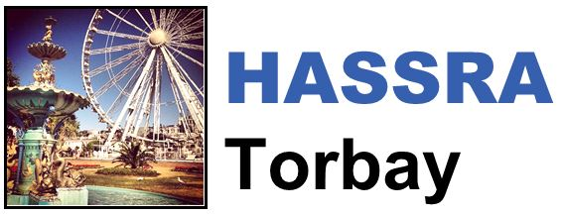

HASSRA Torbay Newsletter

Summer 2023

Hello and welcome to the latest edition of the HASSRA Torbay newsletter

**What’s been going on?**

Your HASSRA Torbay Committee has been busy organising various activities for you to get involved in. Thank you for taking part.

|  |  |  |
| --- | --- | --- |
| **Site Funding**  A picture of an Easter bunny surrounded by Easter Eggs  Four of our Torbay sites took up the offer of funding towards Easter activities. Some ran a raffle and others gave out free treats to staff | **Wildlife Limericks**  Image of a bird, bee, plants and the sun  The Wildlife Limerick competition runs until 30.06.23. Send us your humorous wildlife limericks for the chance to win a £20 Love2Shop voucher. | **Coronation Quiz**  Image of a crown  Five lucky winners each received a HASSRA tote bag and Cream Tea for Two voucher by correctly answering questions about the Coronation |

Remember that our **“Visit the Civet”** competition started in May and runs until September. Send us a photo of you outside the Civet enclosure at Shaldon Zoo for the chance to win 1 of 3 £10 Love to Shop Vouchers.

**HASSRA = Happiness**

In each newsletter, one of our members tells us about how they have been making the most of their membership. For this edition, we’ve been speaking toDebbie Kain from Cotswold House.

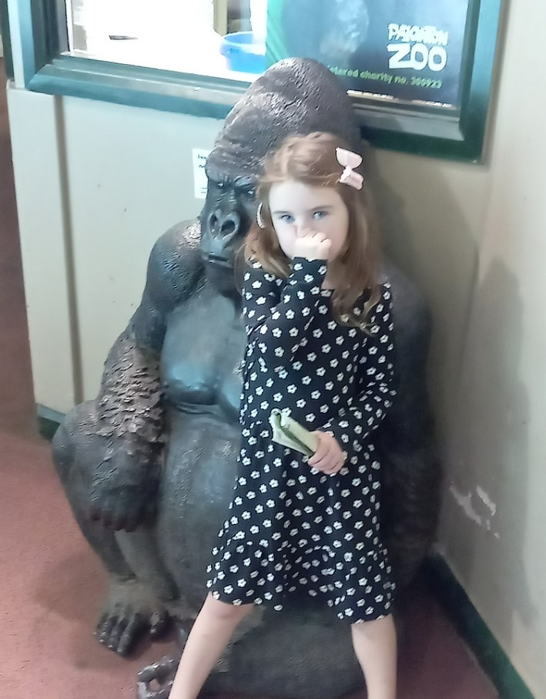

“I love using my HASSRA membership to go on discounted local days out with my family and friends. As you can see from my photos, Paignton Zoo is a bit of a favourite with the children, but in the past year we’ve also been to Crealy and Longleat.

The discounts are great – When we visited Paignton Zoo, it would have cost £22.50 for each adult and £13.90 per child full price, but I bought our tickets through my HASSRA Live account for a fraction of the cost.



I don’t *just* love the national discounts that I get with HASSRA, I also love everything that HASSRA Torbay has to offer too. Through their Christmas 2022 rebate, I received some money back after going on the Christmas Train, and I’ve also won gift cards on their local raffles.”

If you would like to be featured in a future newsletter, email your HASSRA story and photos to Tara Sanders

**What’s coming up?**



Keep an eye out for these Summer activities:

* Summer Site Funding for Healthy Activities
* “Social Summer” rebate

Thank you to everyone who filled in our members survey throughout May.

You’ve all given us lots of ideas for future events and activities, so watch this space for more HASSRA Torbay fun to come.

**Featured offers this season**

Are you heading off on holiday this summer? Don’t forget to check out the “Holidays” section of your HASSRA Live account for details about the following discounts:

* Special rates for Airport Parking and Hotels
* Discounts when booking holidays at Butlins, Haven, Hoseasons, Parkdean
* Offers with independent travel agency Xpert Travel
* Special prices with Warner Leisure Hotels and Hilton Hotels
* Promotional Offers with Fred Olsen Cruises

Remember to regularly check your HASSRA Live Account for all the latest National and South West offers and competitions: [Link to HASSRA Live](https://www.hassra.org.uk/sign-in?return_url=%2F%3FpxRatio%3D1.5&return_key=2d67aef2f8aedb0c905eedbfda14cfcccea7da3c7f09266af1d4f49828dcbac5)

You can also join the HASSRA Lottery via HASSRA Live – Two HASSRA Torbay members won in May, their prizes totalling £600…You have to be in it to win it.