**HASSRA LIVE DESK AID**

**Setting up a HASSRA Club or Regional competition on HASSRA Live.**

**Introduction.**

This desk aid provides step-by-step instructions for approved club and regional officials to run competitions on HASSRA Live.

**Step 1 – Access.**

With the permission of your Regional or Local committee, volunteers can be provided with system access to create competitions and events on HASSRA Live. Please contact the HASSRA National Team via 'Make an enquiry' which is situated at the bottom of '[My Profile page](https://www.hassra.org.uk/profile)' and you will provided with the relevant access and training material..

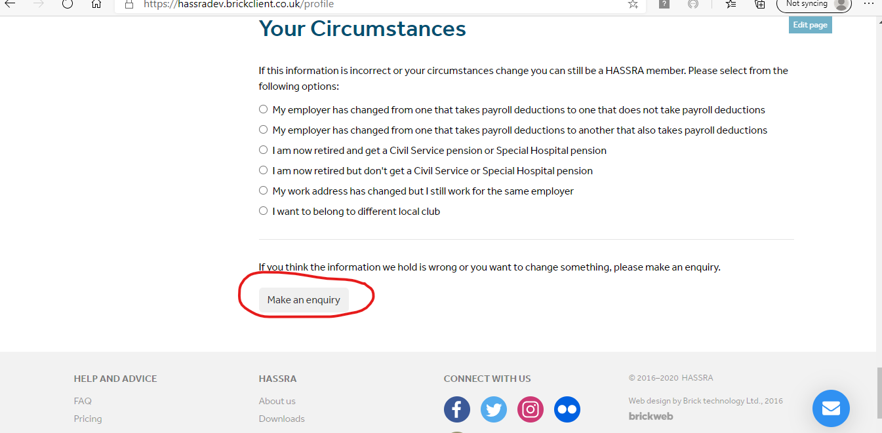

**Step 2 – Preparation.**

Agree with your club/region the details of the competition to include the following.

* Start date and finish dates of the competition.
* Date the draw will be run.
* Full details of the prizes.
* Rules of the competition.

**Step 3 – Organise Competition.**

Log into your HASSRA Live account as normal. Once you have logged into your HASSRA Live account click on your name in the right hand corner.



This will then take you to **‘Your account’** page. Click on the **‘Organiser Activity’** icon.

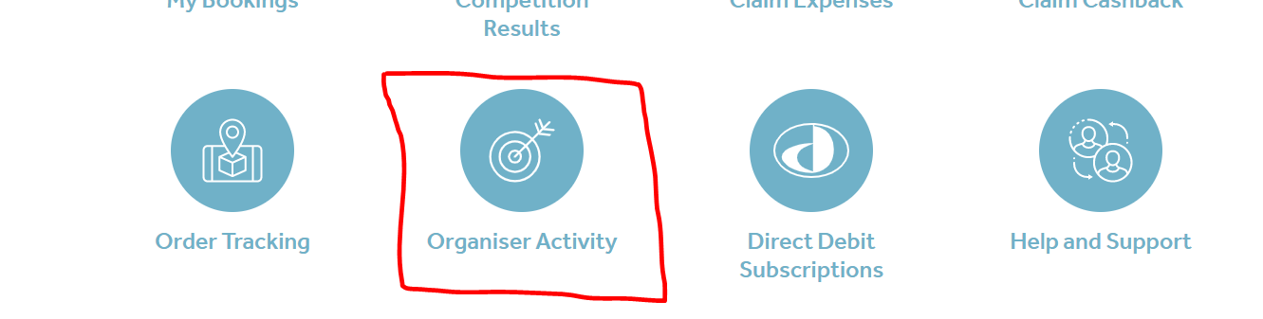

The **Organiser Activity** page is where you input the details of your club’s competition.

**Step 4 – Organiser Activity.**

Choose **‘All competitions’** and then the **‘Create competition’** button.

**Step 5 – Create Competition.**

This is where you will start to input the details of the competition.

* Enter the title of your competition. Keep the title short and snappy.
* Competition start date. This is the date when the competition starts and is launched on HASSRA Live.
* Enter the date the draw will take place.
* If you are a club volunteer the ‘Type’ will remain protected to ‘Club’. Your club will be shown in the local club row, but you are still required to tick the box. Regional volunteers will also have a drop down menu to choose from.
* Click the Create button.

Your competition will be created and be given an unique ID number.

**Step – 6 General Details.**

Once you have clicked on the ‘Continue’ button you will have the General Details page. This is where you will add more details of your competition. Some of the rows will be already populated from the ‘Create competition’ page but this gives you the opportunity to add more details about your competition.

**Step – 7 Design of your competition.**

This is where you can enter more details of your competition.

**Short Description**.

This is displayed as an icon on HASSRA Live so there should just be enough information to get members to click on the icon and enter the competition.

**Full Description**.

Enter the rules and prize details of the competition. Do not enter the competition question/s here. This is later.

**Step – 8 Images and logos.**

Once you have completed the design information of your competition scroll down to add images or logo. You are able to upload five images or logos. Click on the browse button to upload the image or logo from your PC. The first image will appear as an icon on your club’s page.

**Please note** that if you are using ‘copyright-free’ images or logos, or if you are using any that require a licence you will need to obtain permission to use it first. For more information, please contact the [HASSRA Helpdesk](https://help.hassrashop.org.uk/).

**Step – 9 Draw Details.**

You should enter the number of winners in the draw details rows. If there is more than one prize tick the box to specify the number of prizes. Boxes will then appear for you to complete. Please note, the number of boxes will depend on the number of prizes you have input. You can then input the prizes.

**Step – 10 Questions.**

Input the competition questions you want your HASSRA club members to answer.

You are able to include a clue in the optional help row. This may not be necessary in all cases.

You have to give a minimum of at least two multiple choice answers for HASSRA club members to choose from.

The first row will be the assumed correct answer and will appear in the correct answer row. You can set the actual correct answer by adding more pre-set responses and selecting the correct answer from the list.

Please ensure the correct answer is properly selected, as the system will only select winners from the correct entries when the draw is conducted.

You can add several questions if you wish. Click on the Add question button and repeat the process.

Remember to click on the Save button.

**Step – 11 Preview.**

Once saved you will need to preview and submit your competition. Click on the word **‘here’** on the prompt.



This will then take you to the Organiser Activity page where you will have basic details of the competition and other actions.

If you click on ‘Preview’ you will see a copy of what your members will see when the click on your competition.

**Step – 12 Amendments**.

There will be a number of warning messages in red. These will not be visible to the members. If there is anything that needs to be amended, you will need to go back to the main ‘Competitions’ page by clicking the link at the top.

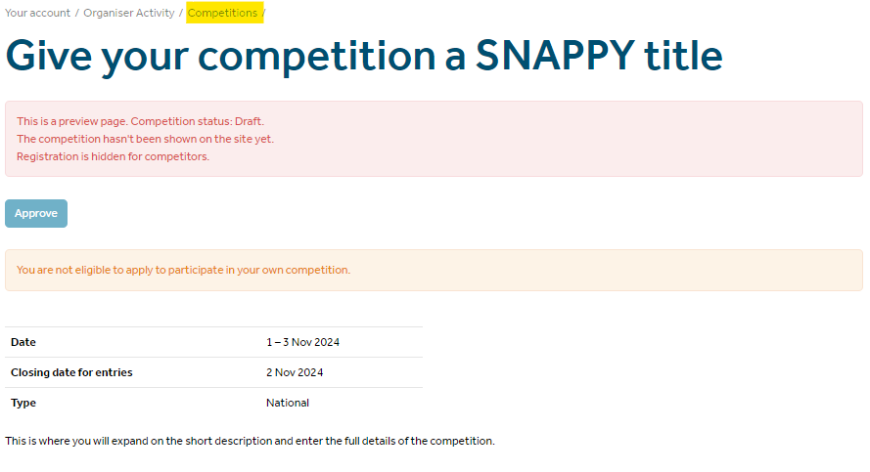

Click on **‘Edit’**. This will take you back to the general details page where you would have originally input the competition details. You will be able to make any necessary amendments.

**Step -14 Approve.**

Once you have checked the competition’s details are correct and you are happy you will need to click on ‘**Approve’**.

You will then see an onscreen box confirming that you are happy and that you want to approve the competition.

Once you have clicked on OK the status will change to ‘Approved’.

**Step – 15 Make Live.**

To ensure your competition appears on HASSRA Live you will need to click on ‘Make Live’. Once you have done this your HASSRA Club members will be able to see your competition.

**Step – 16 WIN section.**

The competition will appear on the ‘**Win’** section of HASSRA Live.

Click on the ‘**Win’** tab and ensure the drop down is changed to ‘Club or Region’. You need to ensure the name of your Club or Region is selected accordingly.

Your members will be able to click on the link which then will take them into the competition. They will have up to 23:59 on the closing date to enter the competition.

If you have any concerns or if you need any more information, please contact the [HASSRA Helpdesk](https://help.hassrashop.org.uk/).